AC module Installation Steps Instructions
（These Instructions apply to YC500A/YC500i/YC600）
Tools required：
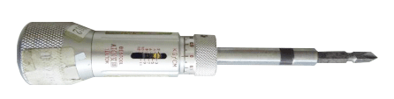
Cross torque screwdriver（or electric screwdriver with torque regulating function）

Accessories required：
1. AC module mounting plate×2 2.M4 ×16 Cross recessed countersunk head screws ×4
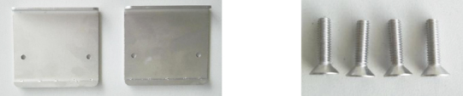

Installation steps:

1、Mount the AC module mounting plate on the bracket by M4 countersunk head screws（the screws do not need to tighten).
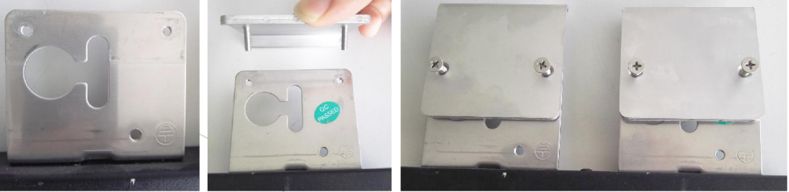

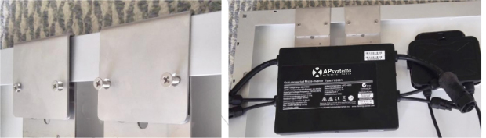
2、Let the complete installed bracket into the module frame from the bottom to top and make the frame embed between the bracket and the AC module mounting plate.

3、Tighten the four M4 countersunk head screws in turn(torque：1.0±0.1NM).
